Screenshot in which you cat /opt/book/ encryption/results/<your company name>.pub (10 points)

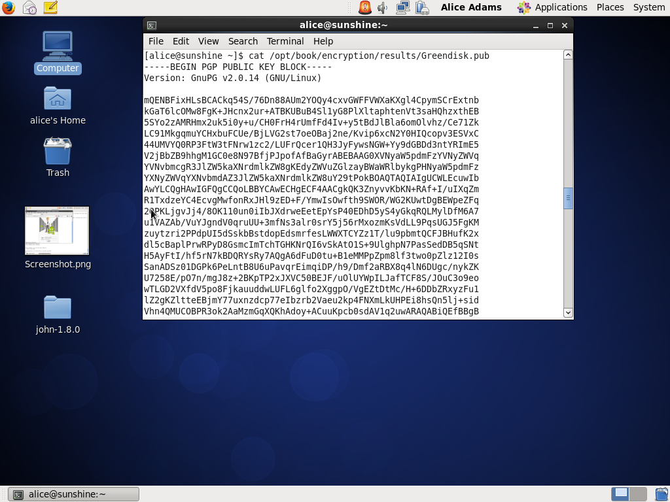

Screenshot in which you cat /opt/book/encryp- tion/results/<your company name>-public-keyring.txt (10 points)

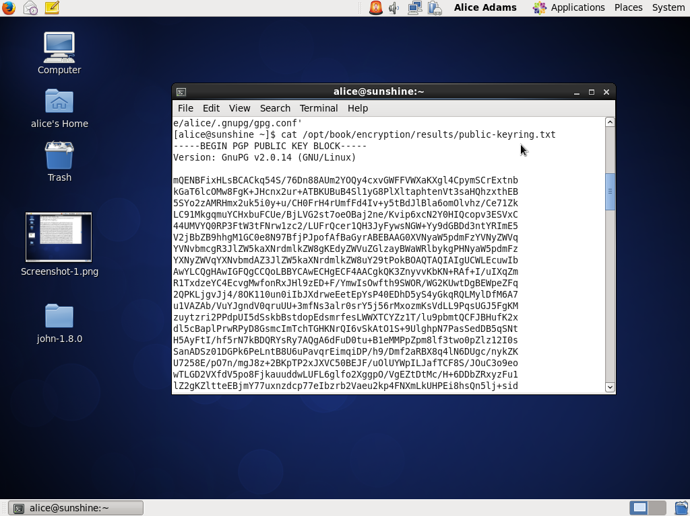

Screenshot in which you cat / opt/book/encryption/results/<your company name>-private-keyring.txt (10 points)

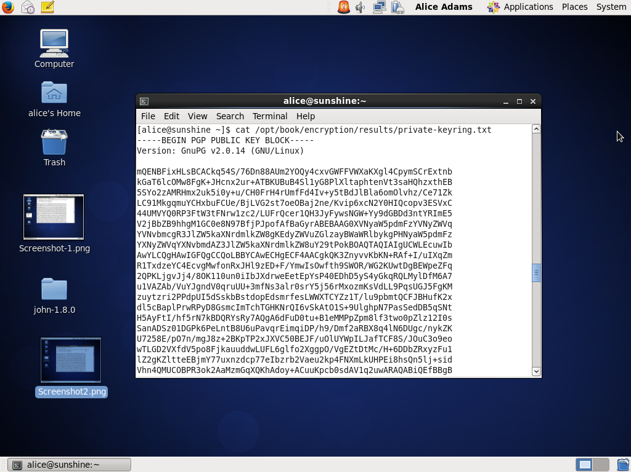

Screenshot in which you cat /opt/book/encryption/results/<your company name>_IT648_encrypted.asc (20 points)

